Expense Reports
Date: 04/28/2024
To: NHWSB
From: Linnea Becerra, OAS

Expense Reports Information
Expense reports are covered in chapter 15 of the Commissioners Plan on pages 68-71. Expense reports are unique to each member and include a vendor number. Please follow these guidelines when completing reports:
- Fill out one report per day or event/meeting.
- The grey example line establishes the distance from the members home to DLI and is not included in subtotals.
- Make sure there is a date in each date box.
- Be as specific as possible when filling in the description box.
- Include the per diem amount once per day, regardless of how many meetings you attended that day.
- Upon completion sign and date, the report then submit to the office administrator.

Example Report:
Below is an example expense report.
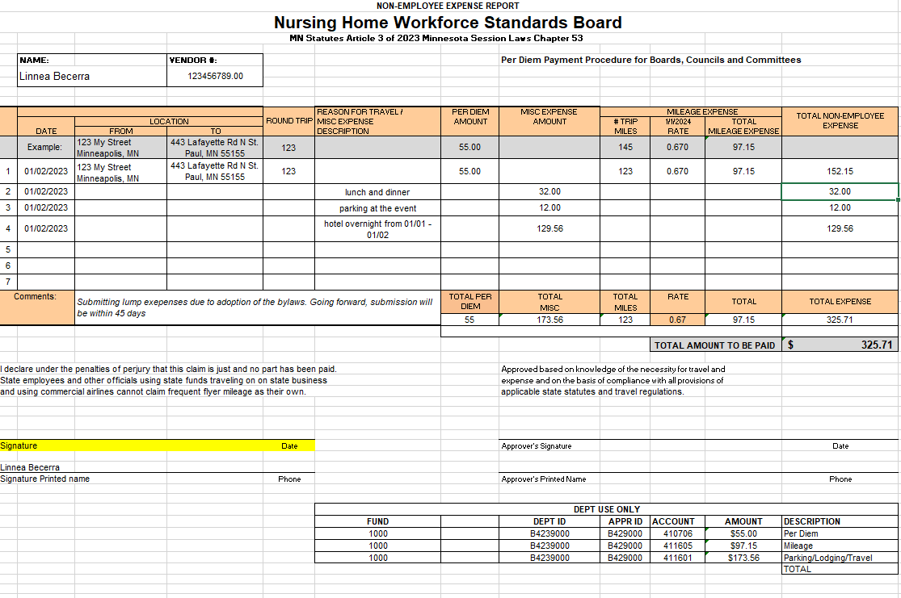

Hotel Guidelines:
To stay overnight in a hotel, please follow the guidelines below:
- Reach out to the Office Administrator at least 48 prior to the reservation. The department will book the hotel and send the confirmation and instructions to the members.
- Keep receipts for supplemental expenses and submit with the expense report.
- If you book a hotel for a board related event or meeting, retain the receipt, and add it as a line on the expense report.

Meal Guidelines:
Meal | Travel Status | Reimbursement Amount
*Breakfast | - be in travel status before 6 am  or  - away from home overnight | 11.00
Lunch | - be more than 35 miles from home | 13.00
Dinner | - be in travel status after 7 pm  or  - away from home overnight | 19.00
“Employees who are in travel status for two (2) or more consecutive meals shall be reimbursed for the actual costs of the meals including tax and a reasonable gratuity, up to the combined maximum amount for the reimbursable meals.”

Combined maximums:
- Breakfast and Lunch- 24.00
- Lunch and Dinner- 34.00
- Dinner and Breakfast- 30.00
*If breakfast is provided at the hotel in which you are staying, you cannot be reimbursed for an outside meal

Notes:
Reach out to the office administrator Linnea Becerra, with any questions regarding your reimbursable expenses.

